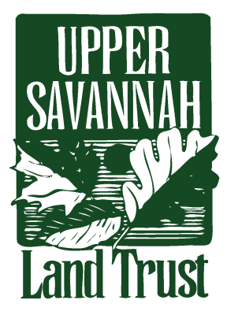
CONSERVATION
The Upper Savannah Land Trust

We Need Your Support
The Upper Savannah Land Trust is a 501 © (3) membership organization dedicated to protecting the natural beauty and integrity of our area.
You can become a supporter in this effort by joining the Upper Savannah Land Trust as a member in one of these categories:
$50 - $99 – Friend | $100 - $249 – Family | $250 - $499 – Patron
$500 - $999 –Sponsor | $1000 - $1499 – Guardian | $1500 - $2999 – Foundation
$3000 or more – Savannah/Saluda Society

Name(s):

Street Address or P.O. Box:

City/ State/ Zip:

Telephone:

Fax:
Please send this form with your remittance to:

Upper Savannah Land Trust
430 Helix Road
Greenwood, SC 29646
Thank you

